Beginner Fridrich Method or CFOP
Sides
[Bas.] U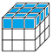F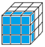R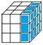L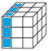D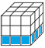B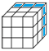 [Adv.] M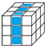S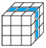E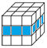
u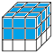f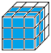r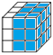l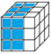d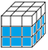b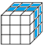
Turns
[Bas.] U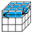F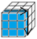R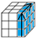L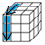DB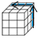 [Adv.] M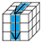S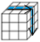E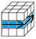
U’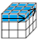F’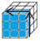R’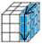L’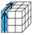D’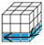B’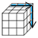M’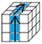S’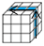E’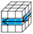
u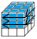f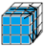r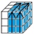l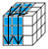d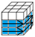b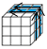
u’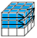f’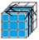r’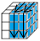l’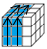d’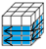b’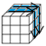
Rotations
(x)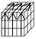(x’)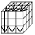(y)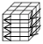(y’)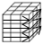(z)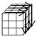(z’)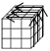
Cross (Top) (White Side Up)
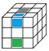= F2 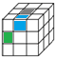= F 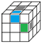= F’ 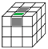= F U’ R U
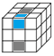= D R F’ R’ 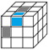= U L’ U’ 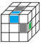= U’ R U
Other Positions
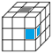 R’ D’ R Then use one of the above positions
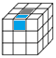 F2 Then use one of the above positions

F2L (First 2 Layers) Part 1 (Corners) (White Side Up)
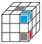 F D F’ 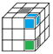 R’ D’ R 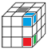 R’ D2 R D R’ D’ R
D’ R’ D R D F D’ F’ F D2 F’ D’ F D F’
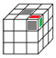 F D F’ D’ F D F’ 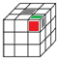 R’ D’ R D R’ D’ R
R’ D R F D F’ F D’ F’ R’ D’ R
Other Positions
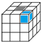 R’ D’ R Then use one of the above positions
F2L (First 2 Layers) Part 2 (Middle Layer) (Yellow Side Up)
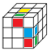 U R U’ R’ U’ F’ U F 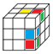 U’ F’ U F U R U’ R’
(y) U F L’ U’ L U L F’ L’ U’ F’ R U R’ U’ R’ F R
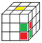 R U’ R’ d R’ U2 R U2 R’ U R [optional]
Other Positions
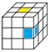 U R U’ R’ U’ F’ U F Then use one of the above positions
OLL (Orientation of Last Layer)
1st Look – Edges
0 Edges
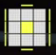 F (R U R’ U’) F’ f (R U R’ U’) f’
f (R U R’ U’) f’ U F (R U R’ U’) F’
2 Adjacent Edges
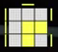 f (R U R’ U’) f’
2 Opposite Edges
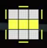 F (R U R’ U’) F’
2nd Look – Corners
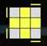 R U2 R2 U’ R2 U’ R2 U2 R
f (R U R’ U’) f’ F (R U R’ U’) F’
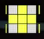 (y) F (R U R’ U’) (R U R’ U’) (R U R’ U’) F’
R’ U’ R U’ R’ U R U’ R’ U2 R
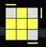 R U R’ U R U2 R’
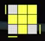 R U2 R’ U’ R U’ R
R2 D R’ U2 R D’ R’ U2 R’
r U R’ U’ r’ F R F’
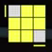 (x) U’ L U R’ U’ L’ U R
(y) l’ U’ L’ U R U’ L U
(y2 x’) R U’ R’ D R U R’ D’
PLL (Permutation of Last Layer)
0 Headlights (Perform T Perm in Any Position; Then Refer to 1 Headlight)
T Perm
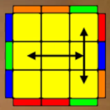 (R U R’ U’) R’ F (R2 U’ R’ U’) (R U R’ F’)
1 Headlight (Headlight Aligned on Left Face)
T Perm
(R U R’ U’) R’ F (R2 U’ R’ U’) (R U R’ F’)
4 Headlights (Corners Aligned)
U(a) Perm
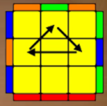 R2 U (R U R’ U’) R’ U’ R’ U R’
U(b) Perm
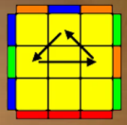 R U’ R U R U R U’ R’ U’ R2
H Perm
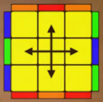 M2 U M2 U2 M2 U M2
Z Perm
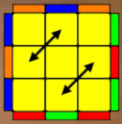 M2 U M2 U M’ U2 M2 U2 M’ U2
(y) M2 U’ M2 U’ M’ U2 M2 U2 M’ U2

